**Module 6 & Module 7**

Name: Anandakrishnan k v

Batch id: 30082021

1. The dataset is from the National Institute of Diabetes and Digestive and Kidney Diseases. The objective of the dataset is to diagnostically predict whether a patient has diabetes using a simple ANN model

Ans:-

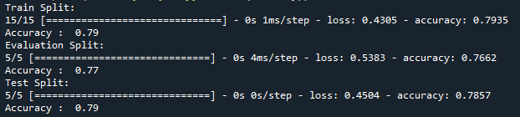

C:\Users\Admin\Documents\diabe.png

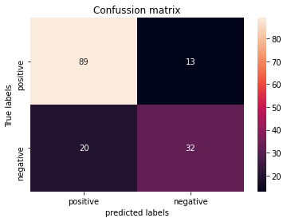

1. Build a ANN model to predict whether a customer will churn or not. Use the attached dataset(Churn_Modelling.csv)

Ans:-

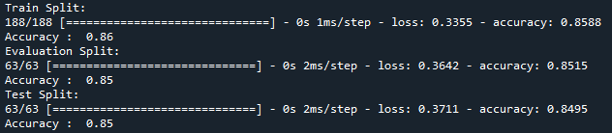

C:\Users\Admin\Documents\chu.png

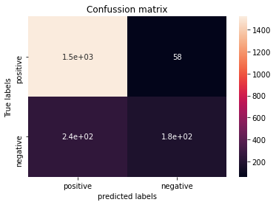

1. Build a ANN classification model to predict breast cancer(malignant or benign )

Ans:- 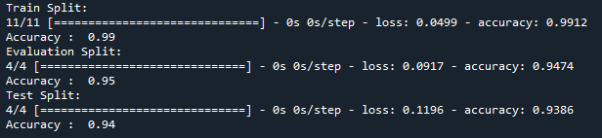

C:\Users\Admin\Documents\canc.png

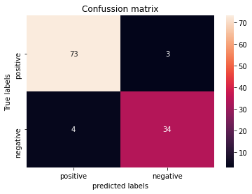

1. If I have a dataset which has images of dogs and cats of size 32x32. I need to predict the output image as a dog or a cat. Fill out the parameters that is used to build a simple ANN model

Input layer should have **32*32 = 1024** number of neurons

Output layer should have **1 or 2** number of neurons

**Sigmoid/TanH** Activation function is used in the output layer

**Binary Cross Entropy** will be the loss function